## HKUSTGZ-AIAA-2205-HW1-Fall-2024

Chang XU 50012819

### Attempts

1. Try running the samples. Try to run the samples and combine three results. For each row, choose the majority result of the three as the result to submit. BAD score: 0.35961
2. Try to find the best methods for this problem. Directly submit mlp, better. score: 0.41228
3. Try add activation='relu’, solver='adam', alpha=0.0001, in the MLPClassifier. slightly better score: 0.41315. Try larger iterate times up to 800. BAD score 0.40789
4. Use Elbow Method, find k = 58 or k = 66 clusters. Retrain MLP. better score 0.44736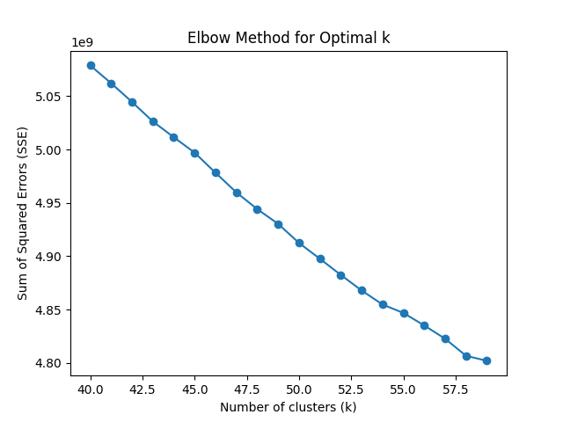图表, 折线图

   描述已自动生成
5. Use Grid Search to search for best hyperparameters for mlp model, and use k-folds cross validation to validate. I get:

Best Parameters: {'activation': 'relu', 'alpha': 0.001, 'hidden_layer_sizes': (500,), 'learning_rate_init': 0.001, 'solver': 'adam'}

Best Score: 0.4667844522968198

In this step, I make the mlp to reach the score of 0.45000 in the private board for k = 66, and reach the score of 0.45614 for k = 100.

1. Try boosting: each step focus on the Residual and use mlp to iterate. This is very bad, only get 0.35263
2. Try XGBoost: Default Parameters get 0.47368
3. Change n_estimators to 300, Change k clusters to 430, get the best score 0.50701. During this period, I use Stratified Cross Validation which is a better choice for validation of classification missions.

### Best Attempt

Use XGBoost, use k clusters and bof430, change the hyperparameters n_estimators = 300, train and run the model.

### Submission and Private Leaderboard

Submission Name: Chang XU

Screenshot:

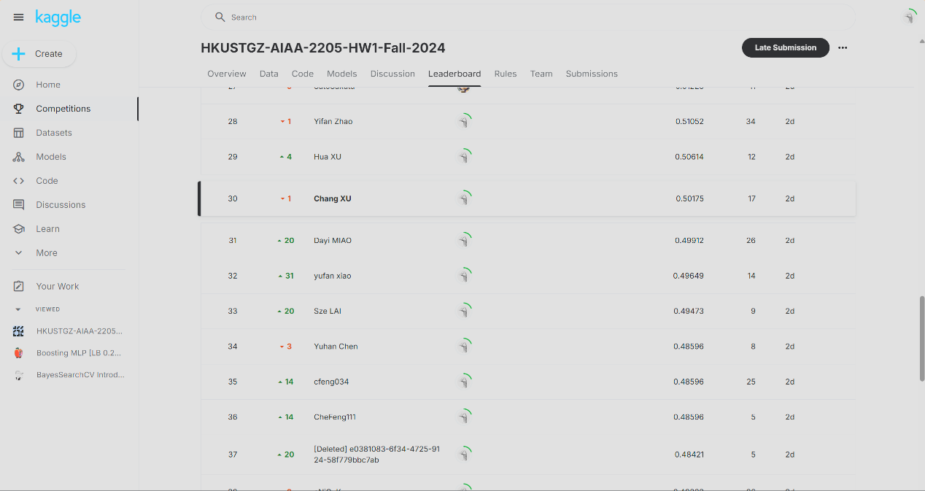

### README

